Exercise Answers for Chapter 2

Exercise 2.1
A. Using the Famous Forms Method. Write the forms of the following arguments. Then use the Famous Forms Method to determine if the arguments are valid. If the validity of an argument cannot be determined in this way, say that it cannot be determined.

Valid—modus ponens
A: You ate it.
F: You’d find out it was spicy.
- A.
- If A, then F.
- So F.

Valid—hypothetical syllogism
F: You flip the switch.
S: You see sparks.
W: You’re doing it wrong.
- If F, then S.
- If S, then W.
- So if F, then W.

Valid—modus tollens
R: God has a reason for such horrible suffering.
K: God has let us know the reasons for such horrible suffering.
- If R, then K.
- Not-K.
- So not-R.

Valid—constructive dilemma
J: There’s a good chance I’ll get the job.
H: I don’t have any hope for a happy life.
S: I’ve set myself up for failure.
H: I don’t have hope for a happy life.
- J or H.
- If J, then S.
- If H, then F.
- So S or F.

Validity is indeterminate by the Famous Forms Method
B: Some pleasures are not beneficial.
W: Some pleasures are not worth experiencing.
P: Those pleasures not worth experiencing are not beneficial.
- B.
- W.
- So P.

Valid—hypothetical syllogism
E: Something exists.
C: Something has a cause.
G: God is the ultimate cause.
- If E, then C.
- If C, then G.
- So if E, then G.

Validity is indeterminate by the Famous Forms Method
L: The best things in life are free.
F: This was free.
G: It’s one of the best things.
- L.
- F.
- So B.

Valid—disjunctive syllogism
S: I got the SAT score I wanted.
H: I’m not getting into Harvard.
- Not-S.
- S or H.
- So H.

Validity is indeterminate by the Famous Forms Method
B: Some of those bins are BPA-containing products.
C: All BPA-containing products are carcinogenic.
F: Some food storage bins are carcinogenic.
- B.
- C.
- So F.

Invalid
C: You clean your room.
E: You should expect to set aside hours of your time.
S: You set aside hours of your time.
P: You’ll miss out on the party.
W: You want to clean your room.
M: You want to miss out on the party.
- If C, E.
- If S, P.
- So if W, then M.
B. Using the Famous Forms Method (Advanced). Follow the same instructions as for exercise A.

Valid—modus ponens
I: If you can get into the party only if you know someone who is already there.
N: No one will be at the party.
  - If I, then N.
  - I.
  - So N.

Valid—modus tollens
L: I’ve lived in Texas.
O: I own a big truck or cowboy boots.
  - If L, then O.
  - Not-O
  - So not-L.

Valid—hypothetical syllogism
U: You will understand me.
N: No one else understands me.
K: You’ll know that no one understands me and try.
  - If N, then K.
  - If K, then U.
  - So if N, then U.

Valid—disjunctive syllogism
T: Taylor will play goalie and we’re sure to win.
J: Jordan will play goalie.
  - T or J.
  - Not-J.
  - So T.

Valid—modus tollens
D: The company’s advertising isn’t deceptive.
R: The company’s advertising did not deceive reasonable people or most people.
  - If D, then R.
  - Not-R.
  - So not-D.

Valid—constructive dilemma
T: Jesus’s claims to be God are true.
F: Jesus made false claims to be God.
L: Jesus is a liar or lunatic
O: Jesus is Lord.
  - T or F.
  - If F, then L.
  - If T, then O.
  - So L or O.

Valid—modus ponens
I: What follows the “and” is an independent cause or an item in a list.
C: You’re supposed to put a comma before the “and.”
  - If C, I.
  - C.
  - So I.

Valid—constructive dilemma
C: I am complimenting you.
S: I am saying something that isn’t a compliment.
I: You’ll construe what I say as an insult.
  - C or S.
  - If C, then I.
  - If S, then I.
  - So I or I.

Valid—hypothetical syllogism
T: You learn about time management.
L: You’ll spend your time listening to a lecture and you’ll learn what you shouldn’t spend your time doing.
S: You’ll realize you should not have spent your time learning about time management.
  - If T, then L.
  - If L, then S.
  - If T, then S.

Valid—constructive dilemma
M: In heaven we can choose to do morally bad things.
G: We can only do good things in heaven.
B: Likely someone will do morally bad things in heaven.
F: We don’t have any freedom in heaven.
- M or G.
- If M, then B.
- If G, then F.
- So B or F.

Exercise 2.2
A. Identifying Argument Forms. Identify the form of each of the following arguments that is most relevant for employing the Counterexample Method.
1. T: Tiger
S: Striped thing
C: Crustacean
a. No T are S.
b. Some C are S.
c. So no C are T.
2. P: Piano music
B: Thing from Beethoven
M: Music by Mozart
a. Some P is B.
b. All M is P.
c. So some M is B.
3. W: You want it.
A: You take action to get it.
S: You’ll be successful.
a. If W and A, then S.
b. Not-S.
c. So not-W.
4. R: Corporations have a responsibility.
P: Corporations’ responsibility is to make a profit.
S: Corporations’ responsibility is just to do what their shareholders want them to do.
a. If R, then S.
b. If S, then P.
c. So if R, then P.
5. U: Unfulfilled desire
P: Painful thing
B: Bad thing
a. Some U are P.
b. Some U are not B.
c. So some P are not B.
6. H: Doctors should honor patients’ wishes not to receive medical treatment.
O: Doctors should violate their obligation to treat patients.
a. If H, then O.
b. Not-O.
c. Not-H.
7. L: License holder
D: Driver
U: Person under sixteen years old
a. All L are D.
b. No U are L.
c. So no U are D.
8. T: You tell me your secrets.
F: We will be friends.
a. T or not-F.
b. T.
c. So F.
9. W: Worship
G: Good thing
P: Thing pleasing to God
a. Some W is G.
b. Some G is P.
c. So all W is P.
10. A: Apple Watch adoption in the United States will rise.
C: Apple will advertise to consumers.
M: There are enough merchants who are willing to accept Apple Pay.
a. If C, then A.
b. If C, then M.
c. So if M, then A.
B. Counterexamples. Construct a good counterexample to each of the following argument forms.
1. If I receive a letter or I receive a package, then I will receive it from FedEx or I will receive it from UPS. I did not receive it from FedEx. So I neither received a letter nor a package.
2. Some students are not athletes. Some athletes are not college students. So some college students are not students.
3. If the bride showed up and the groom showed up, then if the priest showed up, they got married. They didn’t get married, so either the bride didn’t show up or the groom didn’t show up.
4. All members of the Business and Basketball Club are business majors. All members of the Business and Basketball Club are basketball players. So all business majors are basketball players.
5. If you are the richest person in the United States, then you are the founder of Microsoft and you are Bill Gates. So either you’re the richest person in the United States or you’re Bill Gates.
6. No squares are circles. No circles are four-sided figures. So some squares are not four-sided figures.
7. Either I’m going to be right on time or I’m going to be late. If I’m going to be right on time, then I will see the whole movie. If I’m going to be late, I will not see the whole movie. So I’m going to see the whole movie and I will not see the whole movie.
8. All circles are shapes. Some shapes are squares. So some circles are squares.
9. If you have an active iPhone, then you can make calls. If you can make calls, you have signed up with a carrier. If you have a carrier, then you have a national carrier (e.g., Verizon, AT&T) or a local carrier (e.g., U.S. Cellular). You have a national carrier. So you have an active iPhone.
10. All Crayola crayons are crayons. Some crayons are not made by Crayola. So some Crayola crayons are not made by Crayola.

Exercise 2.3
A. Venn Diagrams. Use Venn diagrams to evaluate the following categorical syllogisms. If the Venn diagram allows you to conclude that the syllogism is valid, indicate that it is valid. If the diagram does not, indicate that it does not.
1. Valid
S: Cases of anxiety
M: Cases it is reasonable to be in
P: Cases that involve irrational desires

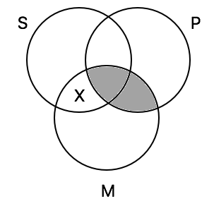

2. Cannot be determined to be valid by Venn diagram
S: Blood transfusions
M: Permissible procedures
P: Procedures that violate the conscience of the patient

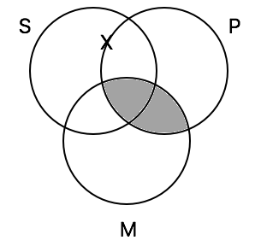

3. Cannot be determined to be valid by Venn diagram
S: Leggings
M: Pants
P: Capris
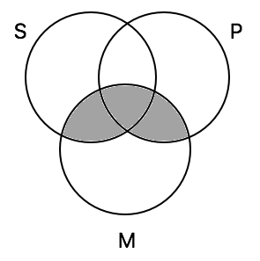

4. Cannot be determined to be valid by Venn diagram
S: Unions that are not liable to fraud
M: Bonded unions
P: Steelworkers unions
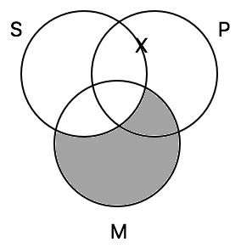

5. Cannot be determined to be valid by Venn diagram
S: Computers
M: Machines that are protected from viruses
P: Machines that are susceptible to hacking
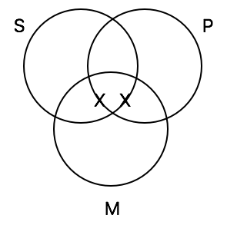

6. Cannot be determined to be valid by Venn diagram
S: Ports that use magical magnetic powers
M: Wireless ports
P: Watch charging ports
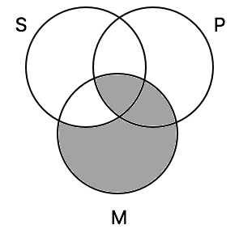

7. Cannot be determined to be valid by Venn diagram
S: Chances to make you a better person
M: Opportunities to practice
P: Logic problems
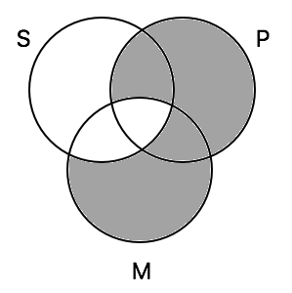

8. Valid
S: Foods with sugar
M: Unhealthy foods
P: Foods that are worthy of your time
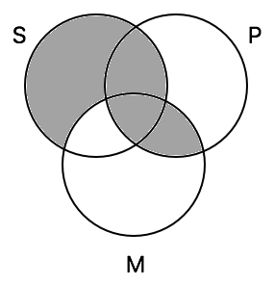

9. Invalid
S: Universities
M: Places that overcharge tuition
P: Places that are worth the investment

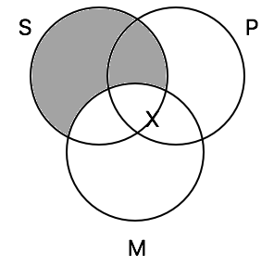

10. Valid
S: Football games
M: Well-attended events
P: Events that need food

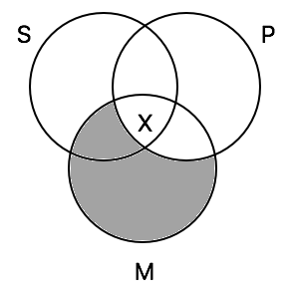

B. Transforming Arguments. Transform each of the following arguments into a categorical syllogism. Then use a Venn diagram to evaluate it. If the diagram allows you to conclude that the argument is valid, indicate that the argument is valid. If it does not, indicate that it does not.

1. Valid
Some people are things that have a disease.
All things that have a disease are things that are sick.
So some people are things that are sick.
S: People
M: Things that have a disease
P: Things that are sick

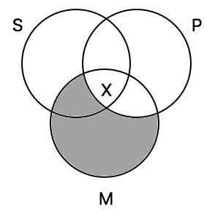

2. Valid
All things that are this report are fraudulent things.
All fraudulent things are things that are produced by a bad person.
So all things that are this report are things that are produced by a bad person.
S: Things that are this report
M: Fraudulent things
P: Things that are produced by a bad person

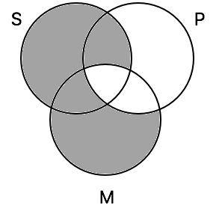

3. Valid
All people who are Jesus are Nazarites.
No good people are Nazarites.
So all people who are Jesus are not good people.
S: People who are Jesus
M: Nazarites
P: Good people

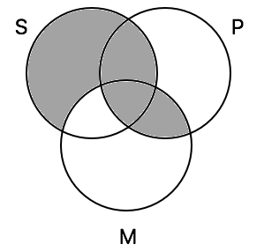

4. Valid
All sales that are up this quarter are sales from the software divisions.
All the sales from the software divisions are recurring revenue sales.
So all sales that are up this quarter are recurring revenue sales.
S: Sales that are up this quarter
M: Sales from the software divisions
P: Recurring revenue sales
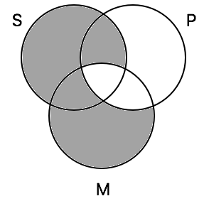

5. Cannot be determined to be valid by Venn diagram
All shipments through Thailand are transactions involving bribes.
Some transactions involving bribes are not impermissible transactions.
So some shipments through Thailand are not impermissible transactions.
S: Shipments through Thailand
M: Transactions involving bribes
P: Impermissible transactions

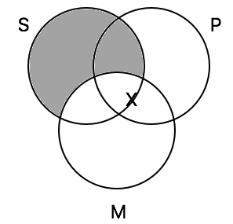

6. Valid
No insider information is information that relies solely on publicly available information.
All information that can be used for stock trading purposes is information that relies solely on publicly available information.
So no insider information is information that can be used for stock trading purposes.
S: Insider information
M: Information that relies solely on publicly available information
P: Information that can be used for stock trading purposes

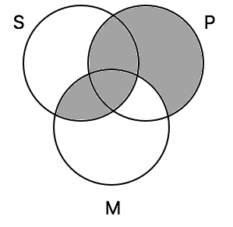

7. Valid
All people who eat contaminated meat are people who get sick.
No person who gets sick is a person who can play basketball well.
So no person who eats contaminated meat is a person who can play basketball well.
S: Person who eats contaminated meat
M: Person who gets sick
P: Person who can play basketball well
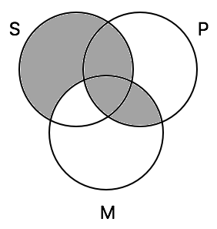

8. Valid
Some students are students who cheat on tests.
No students who are in ethics are students who cheat on tests.
So some students are not students who are in ethics.
S: Students
M: Students who cheat on tests
P: Students who are in ethics
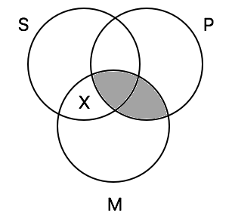

9. Valid
Some breakfast sandwiches are sandwiches containing avocado.
All sandwiches containing avocado are gourmet dishes.
So some breakfast sandwiches are gourmet dishes.
S: Breakfast sandwiches
M: Sandwiches containing avocados
P: Gourmet dishes
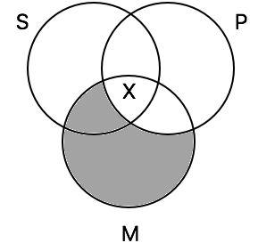

10. Valid
Some person is a person who has lived a completely righteous life.
No person who has lived a completely righteous life is a person who has sinned.
So some person is a person who has not sinned.
S: Person
M: Person who has lived a completely righteous life
P: Person who has sinned
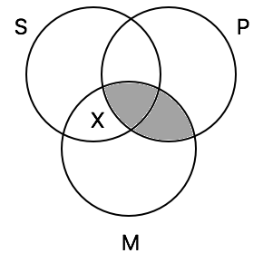

Exercise 2.4
A. Proofs with Rules of Implication. Construct proofs of the following symbolized arguments using the rules of implication.
1.
1. Q * R [premise]
2. R -> ~Q [premise]
3. Q from 1 by Simp

2.
1. ~(P * Q) v ((R v T) -> Q) [premise]
2. ~~(P * Q) * (R v T) [premise]
3. ~~(P * Q) from 2 by Simp
4. (R v T) -> Q from 1,3 by DS
5. R v T from 2 by Simp
6. Q from 4,5 by MP

3.
1. (P v S) -> R [premise]
2. (P -> Q) -> R [premise]
3. (P v S) v (P -> Q) [premise]
4. R v R from 3,1,2 by CD

4.
1. P -> (P -> Q) [premise]
2. P [premise]
3. P -> Q from 1,2 by MP
4. Q from 3,2 by MP

5.
1. ~P -> ~~Q [premise]
2. S -> ~Q [premise]
3. T -> ~P [premise]
4. T [premise]
5. ~P from 3,4 by MP
6. ~~Q from 1,5 by MP
7. ~S from 2,6 by MT

6.
1. (A v T) -> B [premise]
2. R -> (C * ~R) [premise]
3. R [premise]
4. R -> (A v T) [premise]
5. A v T from 4,3 by MP
6. B from 1,5 by MP
7. B v (C * ~R) from 6 by Add
8. (B v (C * ~R)) * (A v T) from 7,5 by Conj

7.
1. A v (B v C) [premise]
2. A -> B [premise]
3. B -> R [premise]
4. C -> S [premise]
5. ~B [premise]
6. ~A from 2,5 by MT
7. B v C from 1,6 by DS
8. C from 7,5 by DS
9. S from 4,8 by MP
10. R v S from 9 by Add

8.
1. (R * S) * (T * V) [premise]
2. R * S from 1 by Simp
3. S from 2 by Simp
4. S v T from 3 by Ddd

9.
1. S [premise]
2. S -> ~(T v L) [premise]
3. L -> (T v L) [premise]
4. ~(T v L) from 2,1 by MP
5. ~L from 3,4 by MT

10.
1. S -> T [premise]
2. T -> L [premise]
3. T -> P [premise]
4. ~P * S [premise]
5. S -> L from 1,2 by HS
6. S from 4 by Simp
7. L from 5,6 by MP
B. Proofs with Rules of Implication and Equivalence. Construct proofs of the following symbolized arguments using the rules of implication or the rules of equivalence.

1.
1. ~(P -> Q) [premise]
2. ~(~P v Q) from 1 by MI
3. ~~P * ~Q from 2 by DeM
4. P * ~Q from 3 by DN

2.
1. ~(~P -> (Q v (R -> Q))) [premise]
2. ~(~~P v (Q v (R -> Q))) from 1 by MI
3. ~(P v (Q v (R -> Q))) from 2 by DN
4. ~P * ~(Q v (R -> Q)) from 3 by DeM
5. ~P from 4 by Simp
6. ~(Q v (R -> Q)) from 4 by Simp
7. ~Q * ~(R -> Q) from 6 by DeM
8. ~Q from 7 by Simp
9. ~(R -> Q) from 7 by Simp
10. ~(~R v Q) from 9 by MI
11. ~~R * Q from 10 by DeM
12. R * Q from 11 by DN
13. R from 12 by Simp
14. ~P * ~Q from 5,8 by Conj
15. ~(P v Q) from 14 by DeM
16. R * ~(P v Q) from 13,16 by Conj

3.
1. ~(P * (~T -> R)) * R [premise]
2. ~(P * (~T -> R)) from 1 by Simp
3. ~P v ~(~T -> R) from 2 by DeM
4. R from 1 by Simp
5. ~~T v R from 4 by Add
6. ~T -> R from 5 by MI
7. ~~(~T -> R) from 6 by DN
8. ~P from 3,7 by DS

4.
1. (~P v ~Q) v Q [premise]
2. ~(P * Q) v Q from 1 by DeM
3. ~(P * Q) v ~~Q from 2 by DN
4. ~((P * Q) * ~Q) from 3 by DeM

5.
1. ~P -> (Q v R) [premise]
2. ~~P v (Q v R) from 1 by MI
3. P v (Q v R) from 2 by DN
4. (P v Q) v R from 3 by As
5. ~~(P v Q) v R from 4 by DN
6. ~(P v Q) -> R from 5 by MI

6.
1. (P * P) v (P * R) [premise]
2. R <–> P [premise]
3. P * (P v R) from 1 by Dist
4. P from 3 by Simp

7.
1. ~(~P v Q) -> ~P [premise]
2. P -> (~P v Q) from 1 by Cont
3. ~P v (~P v Q) from 2 by MI
4. (~P v ~P) v Q from 3 by As
5. ~P v Q from 4 by Red
6. P -> Q from 5 by MI

8.
1. (P v Q) v R [premise]
2. ~R * ~P [premise]
3. ~R from 2 by Simp
4. P v Q from 1,3 by DS
5. ~P from 2 by Simp
6. Q from 4,5 by DS

9.
1. ~R * (~S -> (Q -> R)) [premise]
2. ~S -> (Q -> R) from 1 by Simp
3. ~~S v (Q -> R) from 3 by MI
4. S v (Q -> R) from 3 by DN
5. S v (~Q v R) from 4 by MI
6. (S v ~Q) v R from 5 by As
7. ~R from 1 by Simp
8. S v ~Q from 6,7 by DS
9. ~Q v S from 8 by Comm

10.
1. Q [premise]
2. ~(P v ~P) v Q from 1 by add
3. (P v ~P) -> Q from 2 by MI
C. Indirect Proofs. The following are either arguments or theorems. For the arguments, construct proofs using the rules of implication, equivalence, or indirect proof. For the theorems (the examples with only one line), give a proof of the theorem from no premises.
1.
1. P * ~P Assume for RAA
2. ~(P * ~P) from 1 by RAA

2.
1. ~(P v ~P) Assume for RAA
2. ~P * ~~P from 1 by DeM
3. P v ~P from 1–2 by RAA

3.
1. P v Q Assume for CP
2. ~~P v Q from 1 by DN
3. ~~P v ~~Q from 2 by DN
4. ~(~P * ~Q) from 3 by DeM
5. (P v Q) -> ~(~P * ~Q) from 1–4 by CP
6. ~(~P * ~Q) Assume for CP
7. ~~P v ~~Q from 6 by DeM
8. P v ~~Q from 7 by DN
9. P v Q from 8 by DN
10. ~(~P * ~Q) -> (P v Q) from 6–9 CP
11. ((P v Q) -> ~(~P * ~Q)) * (~(~P * ~Q) -> (P v Q)) from 5,10 by Conj
12. (P v Q) <-> ~(~P * ~Q) from 11 by ME

4.
1. P -> Q assume for CP
2. ~P v Q from 1 by MI
3. (P -> Q) -> (~P v Q) from 1–2 by CP
4. ~P v Q assume for CP
5. P -> Q from 4 by MI
6. (~P v Q) -> (P -> Q) from 4–5 by CP
7. ((P -> Q) -> (~P v Q)) * ((~P v Q) -> (P -> Q)) from 3,6 by Conj
8. (P -> Q) <-> (~P v Q) from 7 by ME

5.
1. (P v Q) v R [premise]
2. Q -> (R v P) [premise]
3. ~P assume for CP
4. ~R assume for RAA
5. P v (Q v R) from 1 by As
6. Q v R from 5,3 by DS
7. Q from 6,4 by DS
8. R v P from 2,7 by MP
9. R from 8,3 by DS
10. R * ~R from 4,9 by Conj
11. R from 4–10 by RAA
12. ~P -> R from 3–11 by CP

6.
1. P assume for CP
2. Q v R assume for CP
3. P * P from 1 by Re
4. P from 3 by Simp
5. (Q v R) -> P from 2–4 by CP
6. P -> ((Q v R) -> P) from 1–5 by CP

7.
1. P -> (~Q v ~S) [premise]
2. (~Q -> R) * (~S -> T) [premise]
3. ~(R v T) [premise]
4. P assume for RAA
5. ~Q v ~S from 1,4 by MP
6. ~Q -> R from 2 by Simp
7. ~S -> T from 2 by Simp
8. R v T from 5,6,7 by CD
9. (R v T) * ~(R v T) from 8,3 by Conj
10. ~P from 4–9 by RAA

8.
1. (P * ~Q) v R [premise]
2. P -> R [premise]
3. ~R assume for RAA
4. P * ~Q from 1,3 by DS
5. P from 4 by Simp
6. R from 2,5 by MP
7. R * ~R from 6,3 by Conj
8. R from 3–7 by RAA

9.
1. R -> ((~S v ~T) * Q) [premise]
2. T assume for CP
3. R assume for CP
4. (~S v ~T) * Q from 1,3 by MP
5. Q from 4 by Simp
6. R -> Q from 3–5 by CP
7. T -> (R -> Q) from 2–6 by CP

10.
1. R * (S -> T) [premise]
2. S assume for CP
3. S -> T from 1 by Simp
4. T from 3,2 by MP
5. R from 1 by Simp
6. ~~T from 4 by DN
7. ~~R from 5 by DN
8. ~~R * ~~T from 7,6 by Conj
9. ~(~R v ~T) from 8 by DeM
10. S -> ~(~R v ~T) from 2–9 by CP
D. Proving English Arguments. Symbolize the following arguments for purposes of using the Proof Method. Then construct proofs of them using any of the rules covered in this section.

P: Price gouging is morally permissible.
H: A company should be allowed to price a good that is necessary for peoples' fundamental well-being excessively high.
D: I should choose which of two drowning victims to save on the basis of who can pay the highest price.

1. P -> H [premise]
2. ~D [premise]
3. ~D -> ~H [premise]
4. ~H from 2,3 by MP
5. ~P from 1,4 by MT

R: We are responsible for our actions.
D: All of our actions are determined by the past together with the laws of nature.
B: Our actions are determined before we were even born.
Q: Our actions are the result of random quantum fluctuations.

1. D v ~D [premise]
2. D -> B [premise]
3. ~D -> Q [premise]
4. (Q v B) -> ~R [premise]
5. Q v B from 1,2,3 by CD
6. ~R From 4,5 MP

D: Death is bad for you.
E: God exists.
L: God is loving.
R: God restores a person back to spiritual health.
T: God causes people everlasting torment.
C: Death is just the end of our existence.
B: We are around to experience bad things.

1. E v ~E [premise]
2. E -> L [premise]
3. L -> (R * ~T) [premise]
4. ~E -> C [premise]
5. C -> ~B [premise]
6. (~B v R) -> ~D [premise]
7. E assume for CP
8. E -> (R * ~T) from 2,3 by HS
9. R * ~T from 7,8 by MP
10. R from 9 by Simp
11. E -> R from 7–10 by CP
12. ~E -> ~B from 4,5 by HS
13. ~B v R from 1,11,12 by CD
14. ~D from 6,13 by MP

G: The defendant will be declared guilty.
T: The defendant will receive fewer than ten years in prison.
N: The defendant will receive prison time.
O: The defendant will spend time out of prison.
J: Justice will be served in this trial.

1. G v ~G [premise]
2. G -> T [premise]
3. ~G -> ~N [premise]
4. (T v ~N) -> O [premise]
5. O -> ~J [premise]
6. T v ~N from 1,2,3 by CD
7. O from 4,6 by MP
8. ~J from 5,7 by MP

T: Whether something is true depends on whether people agree that it's true.
P: People agree that it is true that whether something is true depends on whether people agree to its truth.

1. ~P [premise]
2. (T * ~P) -> ~T [premise]
3. T assume for RAA
4. T * P from 3,4 by Conj
5. ~T from 2,4 by MP
6. T * ~T from 5,3 by Conj
7. ~T from 3–6 by RAA

T: There are things in the universe that do not have to exist.
C: Something is causing to exist the things in the universe that do not have to exist.
O: The things in the universe that do not have to exist cause their own existence.
E: The existence of the things in the universe that do not have to exist is caused by something else.
H: The things in the universe that do not have to exist are ultimately caused by something that has to exist.
D: The things in the universe that do not have to exist are ultimately caused by something that does not have to exist.
I: There is an infinite number of causes.
G: God exists.

1. T [premise]
2. T -> C [premise]
3. C -> (O v E) [premise]
4. ~O [premise]
5. E -> (H v D) [premise]
6. D -> I [premise]
7. ~I [premise]
8. H -> G [premise]
9. C from 1,2 by MP
10. O v E from 9,3 by MP
11. E from 10,4 by DS
12. H v D from 5,11 by MP
13. G v I from 12,8,6 by CD
14. G from 13,7 by DS

U: Utilitarianism is true.
D: A doctor could harvest the organs of one healthy patient without the patient’s consent to save five sick patients in need of organs.
K: The doctor would feel remorse or someone else would know about the operation.
R: The doctor does the right thing.

1. U -> ((D * ~K) -> R) [premise]
2. ~((D * ~K) -> R) [premise]
3. ~U assume for RAA

F: Fetuses have a right to life.
A: Abortion is morally permissible.
I: Infants have a right to life.
M: Fetuses and infants have relevantly similar mental capacities.

1. F -> ~A [premise]
2. M -> (~F -> ~I) [premise]
3. M [premise]
4. A assume for CP
5. ~F from 1,4 by MT
6. ~F -> ~I from 2,3 by MP
7. ~I from 5,6 by MP
8. A -> ~I from 4–7 by CP

T: Today is Tuesday.
R: Today is Thursday.
L: Jane will attend logic class.
E: Jane will attend ethics class.

1. (T v R) -> (L * E) [premise]
2. T v R assume for CP
3. L * E from 1,2 by MP
4. L from 3 by Simp
5. (T v R) -> L from 2–4 by CP
6. ~(T v R) v L from 5 by MI

I: Capital punishment is permissible.
E: Capital punishment is an effective deterrent for the offender.
L: Capital punishment ends the life of an offender.
A: Capital punishment makes committing the crime appealing for the offender.

1. P -> E [premise]
2. L [premise]
3. (L v A) -> ~E [premise]
4. P assume for RAA
5. E from 1,4 by MP
6. L v A from 2 by Add
7. ~E from 6,3 by MP
8. E * ~E from 5,7 by Conj
9. ~P from 4–8 by RAA

Exercise 2.5
A. New Vocabulary. Symbolize the following statements using the symbols of the Proof Method and the new symbols introduced for the Expanded Proof Method. Pick your own symbols for predicates, variables, and constants within the parameters set by this section.

Fx = x is a freshwater fish
Sx = x has scales
∀x(Fx -> Sx)

Dx = x drinks alcohol in the United States
Tx = x is at least twenty-one years old
∀x(Dx -> Tx)

Px = x is a person
Bx = x believes a deity exists
∃x(Px * Bx)

Rx = x is a person in this room
Sx = x has a birthday in September
∃x(Rx * Sx)

Rx = x should be let out of this room by you
Px = x says the password
Sx = x hears scratching sounds
a = you
c = me
Rc -> (Pc v Sa)

Lx = x loves
b = Bob
∀x(Lx -> Lb)

Lx = x is loved
b = Bob
Lb & ∀x(Lx)

Hx = x is here
Fx = x will be found
Px = x will be poor
t = treasure
Ht * (Ft v ∀x(Px))

Px = x is a good gift
Rx = x is a perfect gift
Gx = x comes from God
∀x((Px * Rx) -> Gx)

Gx = x is thought of by God
Dx = x is desired by someone else
∀x(Gx v Dx) or ~∃x(~(Gx v Dx))

B. Proofs for Symbolized Arguments. Provide a proof for each of the following symbolized arguments using the Expanded Proof Method.
1.
1. ∀x(Fx <-> Gx) [premise]
2. ∀x(Fx) assume for CP
3. Fa assume for indirect ∀-introduction
4. Fa <-> Ga from 1 by ∀-elimination
5. (Fa -> Ga) * (Ga -> Fa) from 4 by ME
6. Fa -> Ga from 5 by Simp
7. Ga from 3,6 by MP
8. ∀x(Gx) from 3–7 by indirect ∀-introduction
9. ∀x(Fx) -> ∀x(Gx) from 2–8 by CP
10. ∀x(Gx) assume for CP
11. Ga assume for indirect ∀-introduction
12. Fa <-> Ga from 1 by ∀-elimination
13. (Fa -> Ga) * (Ga -> Fa) from 4 by ME
14. Ga -> Fa from 13 by Simp
15. Fa from 11,14 by MP
16. ∀x(Fx) from 11–16 by indirect ∀-introduction
17. ∀x(Gx) -> ∀x(Fx) from 10–16 by CP
18. (∀x(Fx) -> ∀x(Gx)) * (∀x(Gx) -> ∀x(Fx)) from 9,17 by Conj
19. ∀x(Fx) <-> ∀x(Gx) from 18 by ME

2.
1. ∃x(Fx * Gx) assume for CP
2. Fa * Ga assume for indirect ∃-introduction
3. Fa from 2 by Simp
4. ∃x(Fx) from 2–3 by indirect ∃-introduction
5. Fb * Gb assume for indirect ∃-introduction
6. Gb from 6 by Simp
7. ∃x(Gx) from 5–6 by indirect ∃-introduction
8. ∃x(Fx) * ∃x(Gx) from 4,7 by Conj
9. ∃x(Fx * Gx) -> (∃x(Fx) * ∃x(Gx)) from 1–8 by CP

3.
1. ∀x(Fx * Gx) assume for CP
2. Fa * Ga assume for indirect ∀-introduction
3. Fa from 2 by Simp
4. ∀x(Fx) from 2–3 by indirect ∀-introduction
5. Fb * Gb assume for indirect ∀-introduction
6. Gb from 5 by Simp
7. ∀x(Gx) from 5–6 by indirect ∀-introduction
8. ∀x(Fx) * ∀x(Gx) from 4,7 by Conj
9. ∀x(Fx * Gx) -> (∀x(Fx) * ∀x(Gx)) from 1–8 by CP
10. ∀x(Fx) * ∀x(Gx) assume for CP
11. ∀x(Fx) from 10 by Simp
12. ∀x(Gx) from 10 by Simp
13. Fc assume for indirect ∀-introduction
14. Gc from 12 by ∀-elimination
15. Fc * Gc from 13,14 by Conj
16. ∀x(Fx * Gx) from 13–15 by indirect ∀-introduction
17. (∀x(Fx) * ∀x(Gx)) -> ∀x(Fx * Gx) from 10–16 by CP
18. (∀x(Fx * Gx) -> (∀x(Fx) * ∀x(Gx))) *
(∀x(Fx) * ∀x(Gx)) -> ∀x(Fx * Gx) from 9,17 by Conj
19. ∀x(Fx * Gx) <-> (∀x(Fx) * ∀x(Gx)) from 18 by ME

4.
1. ~(~∀x(Fx <-> Gx) v (∀x(Fx) <-> ∀x(Gx))) assume for RAA
2. ~~∀x(Fx <-> Gx) * ~(∀x(Fx) <-> ∀x(Gx)) from 1 by DeM
3. ∀x(Fx <-> Gx) * ~(∀x(Fx) <-> ∀x(Gx)) from 2 by DN
4. ∀x(Fx <-> Gx) from 3 by Simp
5. ∀x(Fx) assume for CP
6. Fa <-> Ga assume for indirect ∀-introduction
7. Fa from 5 by ∀-elimination
8. (Fa -> Ga) * (Ga -> Fa) from 6 by ME
9. Fa -> Ga from 8 by Simp
10. Ga from 7,9 by MP
11. ∀x(Gx) from 6–10 by indirect ∀-introduction
12. ∀x(Fx) -> ∀x(Gx) from 5–11 by CP
13. ∀x(Gx) assume for CP
14. Ga <-> Fa assume for indirect ∀-introduction
15. Ga from 13 by ∀-elimination
16. (Fa -> Ga) * (Ga -> Fa) from 14 by ME
17. Ga -> Fa from 16 by Simp
18. Fa from 15,17 by MP
19. ∀x(Fx) from 14–18 by indirect ∀- introduction
20. ∀x(Gx) -> ∀x(Fx) from 13–19 by CP
21. (∀x(Fx) -> ∀x(Gx)) * (∀x(Gx) -> ∀x(Fx)) from 12,20 by Conj
22. ∀x(Fx) <-> ∀x(Gx) from 21 by ME
23. ~(∀x(Fx) <-> ∀x(Gx)) from 3 by Simp
24. (∀x(Fx) <-> ∀x(Gx)) * ~(∀x(Fx) <-> ∀x(Gx)) from 22,23 by Conj
25. ~∀x(Fx <-> Gx) v (∀x(Fx) <-> ∀x(Gx)) from 1–24 by RAA

5.
1. ∃x(Fx) v ∃x(Gx) [premise]
2. ∀x(Fx -> Gx) [premise]
3. ~∃x(Gx) assume for RAA
4. ∃x(Fx) from 1,3 by DS
5. Fa assume for indirect ∃-introduction
6. Fa -> Ga from 2 by ∀-elimination
7. Ga from 5,6 by MP
8. ∃x(Gx) from 5–7 by indirect ∃-introduction
9. ∃x(Gx) * ~∃x(Gx) from 3,8 by Conj
10. ∃x(Gx) from 3–9 by RAA

6.
1. ∀x(~(Px -> Qx)) [premise]
2. ∃x(Qx) [premise]
3. ~(Pa -> Qa) assume for indirect ∀-introduction
4. ~(~Pa v Qa) from 3 by MI
5. ~~Pa * ~Qa from 4 by DeM
6. ~Qa from 5 by Simp
7. ∀x(~Qx) from 3–6 by indirect ∀-introduction
8. ~∃x(Qx) from 7 by QE
10. ~Ra assume for RAA
11. ∃x(Qx) * ~∃x(Qx) from 2,10 by Conj
12. Ra from 10–11 by RAA

7.
1. ∀x(~Px v (Qx v Tx)) [premise]
2. ∀x~(~Sx v Tx) [premise]
3. ~Pa v (Qa v Ta) assume for indirect ∀-introduction
4. Pa assume for CP
5. ~~Pa from 4 by DN
6. Qa v Ta from 3,5 by DS
7. ~(~Sa v Ta) from 2 by ∀-elimination
8. ~~Sa * ~Ta from 6 by DeM
9. ~Ta from 8 by Simp
10. Qa from 5,9 by DS
11. Pa -> Qa from 4–10 by CP
12. ∀x(Px -> Qx) from 3–11 by indirect ∀-introduction

8.
1. ∀y(Fa -> (∃x(~Gx) -> Gy)) [premise]
2. ∀x(Gx -> Hx) [premise]
3. ∀x(~Jx -> ~Hx) [premise]
4. ∃x(~Jx) assume for CP
5. ~(~Fa v ∀x(Gx)) assume for RAA
6. ~~Fa * ~∀x(Gx) from 5 by DeM
7. Fa * ~∀x(Gx) from 6 by DN
8. Fa -> (∃x(~Gx)) -> Gb assume for indirect ∀-introduction
9. (Fa * (∃x(~Gx))) -> Gb from 8 by Exp
10. Fa * ∃x(~Gx) from 7 by QE
11. Gb from 9,10 by MP
12. Gb -> Hb from 2 by ∀-elimination
13. Hb from 11,12 by MP
14. ~Jb -> ~Hb from 3 by ∀-elimination
15. Jb from 13,14 by MT
16. ∀x(Jx) from 8–15 by indirect ∀-introduction
17. ~∃x(~Jx) from 16 by QE
18. ∃x(~Jx) * ~∃x(~Jx) from 4,17 by Conj
19. ~Fa v ∀x(Gx) from 5–18 by RAA
20. ∃x(~Jx) -> (~Fa v ∀x(Gx)) from 4–19 by CP

9.
1. ∃x(Fx * Ga) [premise]
2. ∀x(Fx -> Hx) [premise]
3. Fb * Ga assume for indirect ∃-introduction
4. Fb from 3 by Simp
5. Fb -> Hb from 2 by ∀-elimination
6. Hb from 4,5 by MP
7. Fb * Hb from 4,6 by Conj
8. Ga from 3 by Simp
9. Ga * (Fb * Hb) from 7,8 by Conj
10. ∃x(Ga * (Fx * Hx)) from 3–9 by indirect ∃-introduction

10.
1. ∀x(Gx -> ∃y(Fy * Hy)) [premise]
2. ∀x(~Fx) assume for CP
3. Ga -> ∃y(Fy * Hy) assume for indirect ∀-introduction
4. Ga assume for RAA
5. ∃y(Fy * Hy) from 3,4 by MP
6. Fb * Hb assume for indirect ∃-introduction
7. Fb from 6 by Simp
8. ∃x(Fx) from 6–7 by indirect ∃-introduction
9. ~∀x(~Fx) from 8 by QE
10. ∀x(~Fx) * ~∀x(~Fx) from 2,9 by Conj
11. ~Ga from 4–10 by RAA
12. ∀y(~Gy) from 3–11 by indirect ∀-introduction
13. ~∃y(Gy) from 12 by QE
14. ∀x(~Fx) -> ~∃y(Gy) from 2–13 by CP

C. Proofs for English Arguments. Symbolize each of the following English arguments using the symbols of the Proof Method and the Expanded Proof Method. Then provide a proof.
1.
Sx = x is an instance of suffering
h = the Holocaust
Ax = x is allowed by God
Lx = x is an event God is blameworthy for
Mx = x has a morally sufficient reason for occurring
Bx = x is on-balance bad

1. Sh * Ah [premise]
2. ∀x(Sx -> Mx) [premise]
3. ∀x(Mx -> ~Bx) [premise]
4. ∀x(Lx -> Bx) [premise]
5. Sh from 1 by Simp
6. Sh -> Mh from 2 by ∀-elimination
7. Mh -> ~Bh from 3 by ∀-elimination
8. Sh -> ~Bh from 6,7 by HS
9. ~Bh from 5,8 by MP
10. Lh -> Bh from 4 by ∀-elimination
11. ~Lh from 9,10 by MT

Wx = x has the worst evil happen to it
Hx = x is in hell

1. ~∃x(Wx) [premise]
2. ∀x(Hx -> Wx) [premise]
3. ∃x(Hx) assume for RAA
4. Ha assume for indirect ∃-introduction
5. Ha -> Wa from 2 by ∀-elimination
6. Wa from 4,5 by MP
7. ∃x(Wx) from 4–6 by indirect ∃-introduction
8. ∃x(Wx) * ~∃x(Wx) from 7,1 by Conj
9. ~∃x(Hx) from 3–8 by RAA

Tx = x is true
Fx = x is false
Wx = x is worth saying
Sx = x is a statement

1. ∀x((Sx * Wx) -> Tx) [premise]
2. ∀x((Sx * Fx) -> ~Tx) [premise]
3. (Sa * Wa) -> Ta assume for indirect ∀-introduction
4. (Sa * Fa) -> ~Ta from 2 by ∀-elimination
5. Sa * Fa assume for CP
6. ~Ta from 4,5 by MP
7. ~(Sa * Wa) from 3,6 by MT
8. ~Sa v ~Wa from 7 by DeM
9. Sa from 5 by Simp
10. ~~Sa from 9 by DN
11. ~Wa from 9,10 by DS
12. (Sa * Fa) -> ~Wa from 5–11 by CP
13. ~(Sa * Fa) v ~Wa from 12 by MI
14. ~((Sa * Fa) * Wa) from 13 by DeM
15. ∀x~((Sx * Fx) * Wx) from 3–14 by indirect ∀-introduction
16. ~∃x((Sx * Fx) * Wx) from 15 by QE

Ax = x asks for forgiveness
Wx = x has done something wrong
Sx = x is a saint
Mx = x has performed every great moral good

1. ∀x(Mx -> Ax) [premise]
2. ∀x(Ax <-> Wx) [premise]
3. ∀x(Sx -> (Mx * ~Wx)) [premise]
4. Ma -> Aa assume for indirect ∀-introduction
5. Aa <-> Wa from 2 by ∀-elimination
6. (Aa -> Wa) * (Wa -> Aa) from 5 by ME
7. Aa -> Wa from 6 by Simp
8. Ma -> Wa from 4,7 by HS
9. ~Ma v Wa from 8 by MI
10. ~Ma v ~~Wa from 9 by DN
11. ~(Ma * ~Wa) from 10 by DeM
12. Sa -> (Ma * ~Wa) from 3 by ∀-elimination
13. ~Sa from 11,12 by MT
14. Ax(~Sx) from 4–13 by indirect ∀-introduction
15. ~∃x(Sx) from 14 by QE

Px = x is at the party
Fx = x is a friend of mine
b = Bill
m = Melinda
j = Jordan

1. (Pm v Pj) -> Pb [premise]
2. Fb [premise]
3. Pj assume for CP
4. Pm v Pj from 3 by Add
5. Pb from 1,4 by MP
6. Pb * Fb from 5,2 by Conj
7. ∃x(Px * Fx) from 6 by ∃-introduction
8. Pj -> ∃x(Px * Fx) from 3–7 by CP

Rx = x reflects
Bx = x is able to evaluate all their beliefs
Kx = x is able to evaluate whether they know

1. ∀x(Rx -> Bx) [premise]
2. ∀x(Bx -> Kx) [premise]
3. ~(~∃x(Rx) v ~∀x(Rx -> ~Kx)) assume for RAA
4. ~~∃x(Rx) * ~~∀x(Rx -> ~Kx) from 3 by DeM
5. ∃x(Rx) * ~~∀x(Rx -> ~Kx) from 4 by DN
6. ∃x(Rx) * ∀x(Rx -> ~Kx) from 5 by DN
7. ∃x(Rx) from 6 by Simp
8. ∀x(Rx -> ~Kx)) from 6 by Simp
9. Ra -> ~Ka assume for indirect ∀-introduction
10. Ra -> Ba from 1 by ∀-elimination
11. Ba -> Ka from 2 by ∀-elimination
12. Ra -> Ka from 10,11 by HS
13. Ra assume for RAA
14. Ka from 12,13 by MP
15. ~Ka from 9,13 by MP
16. Ka * ~Ka from 14,15 by Conj
17. ~Ra from 13–16 by RAA
18. ∀x(~Rx) from 9–17 by indirect ∀-introduction
19. ~∃x(Rx) from 18 by QE
20. ∃x(Rx) * ~∃x(Rx) from 7,19 Conj
21. ~∃x(Rx) v ~∀x(Rx -> ~Kx) from 3–20 by RAA

Gx = x is God
Ex = x is an evil

1. ∃y(Gy) [premise]
2. ∃x(Ex) [premise]
3. ∀x(Ex -> ~Ey(Gy)) assume for RAA
4. Ea -> ~Ey(Gy) assume for indirect ∀-introduction
5. ~~∃y(Gy) from 1 by DN
6. ~Ea from 5,4 by MT
7. ∀x(~Ex) from 4–6 by indirect ∀-introduction
8. ~∃x(Ex) from 7 by QE
9. ∃x(Ex) * ~∃x(Ex) from 2,9 by Conj
10. ~∀x(Ex -> ~∃y(Gy)) from 3–9 by RAA

Hx = x is an available house on the market
Fx = x is falling apart
Px = x is over your price limit
Bx = x is something you will buy

1. ∀x(Hx -> (Fx v Px)) [premise]
2. ∃x(Hx * Bx) [premise]
3. ∀x(Bx -> ~Px) [premise]
4. Ha * Ba assume for indirect ∃-introduction
5. Ha from 4 by Simp
6. Ha -> (Fa v Pa) from 1 by ∀-elimination
7. Fa v Pa from 5,6 by MP
8. Ba from 4 by Simp
9. Ba -> ~Pa from 3 by ∀-elimination
10. ~Pa from 8,9 by MP
11. Fa from 7,10 by DS
12. Ba * Fa from 8,11 by Conj
13. Ha * (Ba * Fa) from 5,12 by Conj
14. ∃x(Hx * (Bx * Fx)) from 4–13 by indirect ∃-introduction

Bx = x is business done overseas
Vx = x is vetted by foreign officials
Px = x is private
Gx = x is business done by Google

1. ∀x(Bx -> Vx) [premise]
2. ∀x(Vx -> ~Px) [premise]
3. Ba -> Va assume for indirect ∀-introduction
4. Va -> ~Pa from 2 by ∀-elimination
5. Ba -> ~Pa from 3,4 by HS
6. Ga * Ba assume for CP
7. Ba from 6 by Simp
8. ~Pa from 5,7 by MP
9. (Ga * Ba) -> ~Pa from 6–8 by CP
10. ∀x((Gx * Bx) -> ~Px) from 3–9 by indirect ∀-introduction

s = the president’s statement to the media
Lx = x is a lie
Ex = x is expected to be true by the audience

1. ∀x(Lx -> Ex) [premise]
2. ~Es [premise]
3. Ls -> Es from 1 by ∀-elimination
4. ~Ls from 2,3 by MT

